**Instituto Politécnico Nacional**

**Escuela Superior de Cómputo**

*Fundamental Analysis of Circuits*

Practice 2: Ohm Law.

Group: 1CV13

Team: 7

Members:

Pastor Martínez Luis Enrique

Partido Terrón Luis Alberto

Pérez Garduño José Emiliano

Maestro:

Raúl Santillán Luna

Practice day: September 11, 2017

Delivery day: September 18,2017

**Index:**

1. Introduction
2. Development
3. Questionnaire
4. Conclusions

**Introduction:**

Ohmmeter: An ohmmeter is an electrical instrument that measures electrical resistance, the opposition to an electric current. Micro-ohmmeters (microhmmeter or microhmmeter) make low resistance measurements. The unit of measurement for resistance is ohms (Ω).

Voltmeter: A voltmeter is an instrument used for measuring electrical potential difference between two points in an electric circuit. Analog voltmeters move a pointer across a scale in proportion to the voltage of the circuit; digital voltmeters give a numerical display of voltage by use of an analog to digital converter.

Amperemeter: An amperemeter is a measuring instrument used to measure the current in a circuit. Electric currents are measured in amperes (A), hence the name. It is generally represented by letter 'A' in a circle.

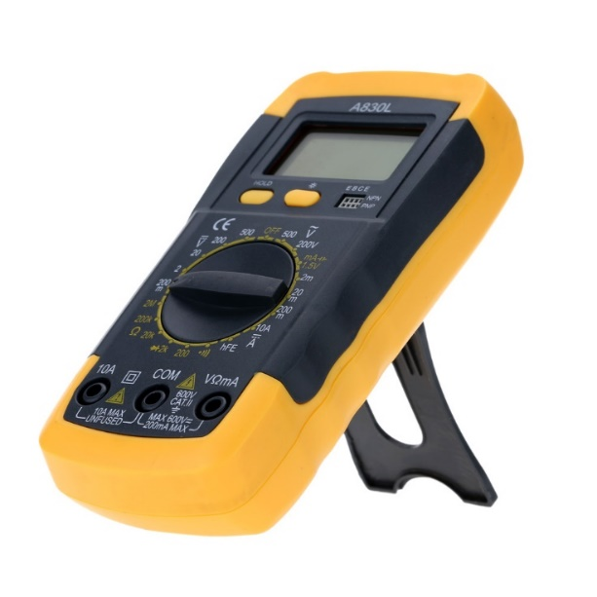

**Development:**

Use of the ohmmeter: without energizing any element of the circuit, measure the value of resistance that each resistor presents, like it´s indicated in the figure 3 and fill the table 1.

|  |  |  |
| --- | --- | --- |
| Resistor | Value in the digital ohmmeter | Value with the color code |
| R1 | 325Ω | 330Ω |
| R2 | 548Ω | 560Ω |
| R3 | 666Ω | 680Ω |
| R4 | 996Ω | 1KΩ |

Use of the voltmeter: In the figure 4 it´s shown how it must be measured the voltage of an element. With the power supply off, arm the circuit in figure 5. Once it´s armed, turn on the power supply and fill table 2.

|  |  |  |  |
| --- | --- | --- | --- |
| Power Supply | Digital Multimeter | | |
| Voltage in R1 and R2 | Voltage in R1 | Voltage in R2 |
| E=1V | 1.02V | 0.77V | 0.23V |
| E=2V | 2V | 1.51V | 0.49V |
| E=3V | 3.07V | 2.32V | 0.75V |
| E=4V | 4.05V | 3.03V | 0.98V |
| E=5V | 5V | 3.78V | 1.22V |
| E=6V | 6V | 4.59V | 1.48V |
| E=7V | 7.1V | 5.37V | 1.73V |
| E=8V | 8V | 6V | 1.97V |
| E=9V | 9V | 6.8V | 2.22V |
| E=10V | 10V | 7.58V | 2.45V |
| E=11V | 11.1V | 8.4V | 2.72V |
| E=12V | 12V | 9.1V | 2.95V |

Use of the Amperemeter:

Figure 6 shows how the amperemeter must be connected for the measurement of current in an element.

|  |  |  |  |
| --- | --- | --- | --- |
| Power Supply | Digital Multimeter | | |
| Current through R1 and R2 | Current through R1 | Current through R2 |
| E=1V | 2.6 mA | 1.4mA | 1.6mA |
| E=2V | 5 mA | 2.6mA | 3mA |
| E=3V | 10mA | 3.9mA | 4.1mA |
| E=4V | 13.1mA | 5.9mA | 7.2mA |
| E=5V | 16.5mA | 7.5mA | 9.1mA |
| E=6V | 20mA | 9mA | 11mA |
| E=7V | 23.1mA | 10.5mA | 12.7mA |
| E=8V | 26.4mA | 12mA | 14.3mA |
| E=9V | 29.8mA | 13.5mA | 16.4mA |
| E=10V | 33.3mA | 15.1mA | 18.7mA |
| E=11V | 36.6mA | 16.7mA | 20.1mA |
| E=12V | 39.9mA | 17mA | 21mA |

Questionnaire:

1. Which is the characteristic of a D.C. circuit?

They share an exclusive node.

1. Which is the characteristic of a parallel circuit?

They share two exclusive nodes simultaneously.

1. Which is the main difference between an analogic and digital measurer?

The digital measurer uses a variable of time and is more precise while the analog measurer catches a signal and can contain more frame of error.

1. Why does an amperemeter must not be connected in parallel?

Because it won´t measure anything and it can damage the equipment.

1. Why do you need to disconnect the circuit when measuring the resistance of an electrical circuit?

If you energize the circuit while measuring resistances then it won´t measure anything and the equipment will get damaged.

**Conclusions:**

Luis Enrique: The practice helps us to make good use of the measuring equipment and helps us to understand the behavior of the elements once energized.

Luis Alberto: The first practice is important because we understand the use of the elements as passive and active, also the interaction between these elements.

José Emiliano: After finishing this practice we learned how to correctly utilize the multimeter, the ways that we can damage it, and how to measure different data in a circuit.